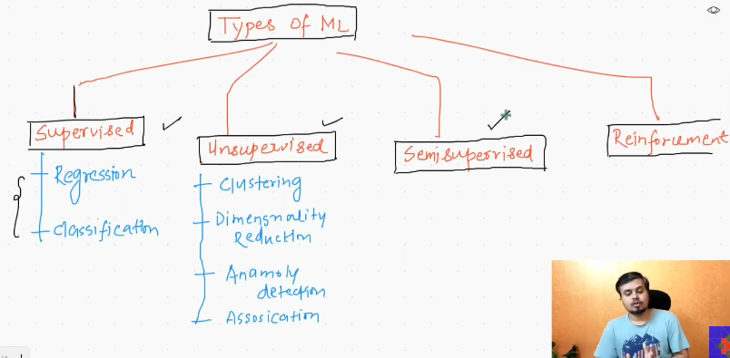
- Semi_supervised learning:
  - It has both types of data. Supervised and unsupervised. Usually the supervised are expensive in nature, need of manual data entry.
  - Ex: Google photos: They use the label data, using those labeled data
- Reinforcement learning:
    - There will be some agents they will be rewarded based on the action they make, negative if they

How machine learning models train in production?
- Batch Machine learning:
  - Giving all data at a time to make the machine to learn.
  - Get the data, train the model and deploy that on the server.
  - 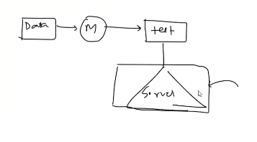
  - Making this in the server:
    - Consumes time
  - Problem:
    - 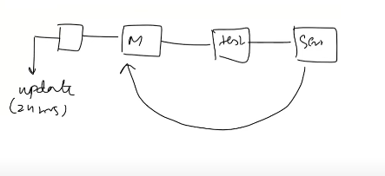
    - 
    - Avaiability: atleast for some hours the model is not trained, till then we will not have the acces to new data.
    - There will be continous updates in day to day data.
- Online machine learning:
  - Statement: Our product improves based on the number of times the users usage.
  - On the server, the machine learning models update based on the mini batch.
  - It is done incremenetally.
  - On server, we will be getting new feeds of data everytime , by using those feeds, we will be making the new models and continuosly deployed.
  - In server(Both are happening):
    - Prediction
    - learning
  - In offline, only the prediction occurs not the learning.
  - Ex: chatbot, swift key, youtube recommendation.
  - Here we train the models sequentially.
- When to use?
    - The nature of problem keeps changing very fastly , ex: stock market. (online), Concept drift:
    - Cost effective: (online)
    - Faster solution: Online.
  - Implemented:
    - linear model: SGD regressor, partial fit in sklearn
    - Dedicated library, river.
    - vowpal wabbit
  - Learning Rate:
    - Determines how fast you learn from new data by keeping the previous data.
    - This is most difficult task.
  - Out of core learning:
    - There are huge set of data, which cannot be loaded at once to RAM.
    - Hence we use the mini batch in offline.
    - 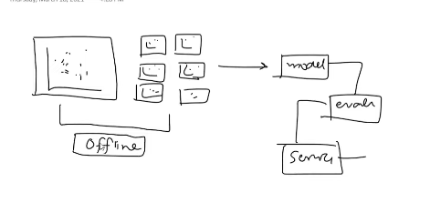
  - Disadvantage:
    - 
      - The machine learning models are generated based on the data we pass, if the data is controlled by some body, then models are gone. Anomoly detection comes in. So when this is made, we will be turning off the server and rollback to the previous models and turn on the server again.
      - 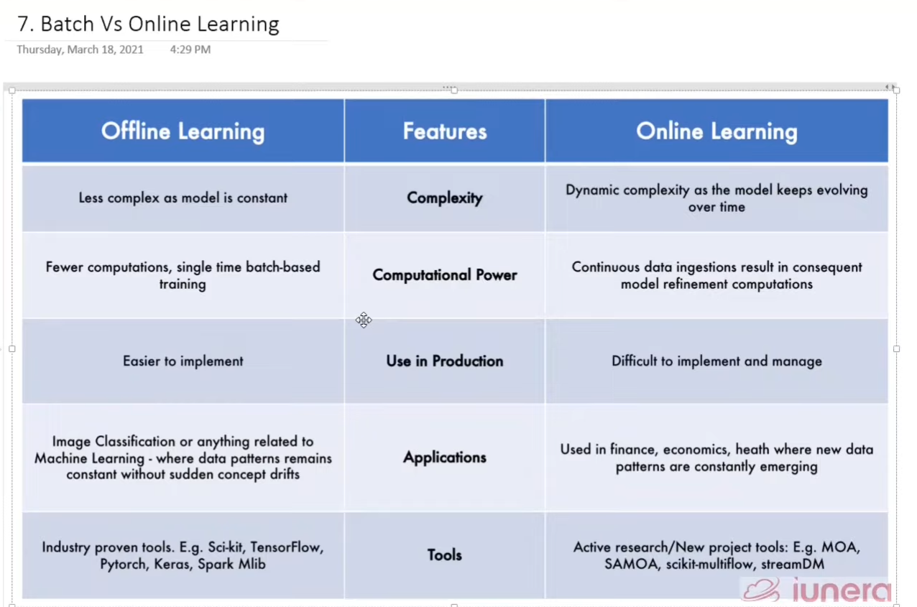

Instance Based Learning vs Model Based Learning:

- Learning:
  - Memorizing (instance based)
  - Generalizing- extracting the fundamental principles or patterns( Model based learning).
- Instance based:
  - 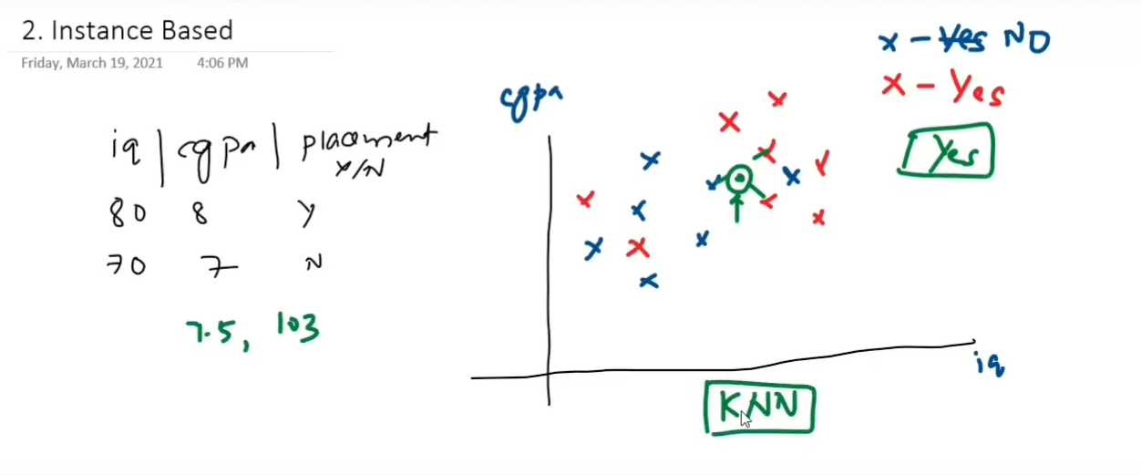
  - We first collect all the data points. A new random point comes, based on the k nearest negihbours we declare the point is similiar to that.
  - It doe not learn anything from data.
- Model Based Learning:
  - Makes the mathematical equation out of data. Then we use this for future prediction.
- 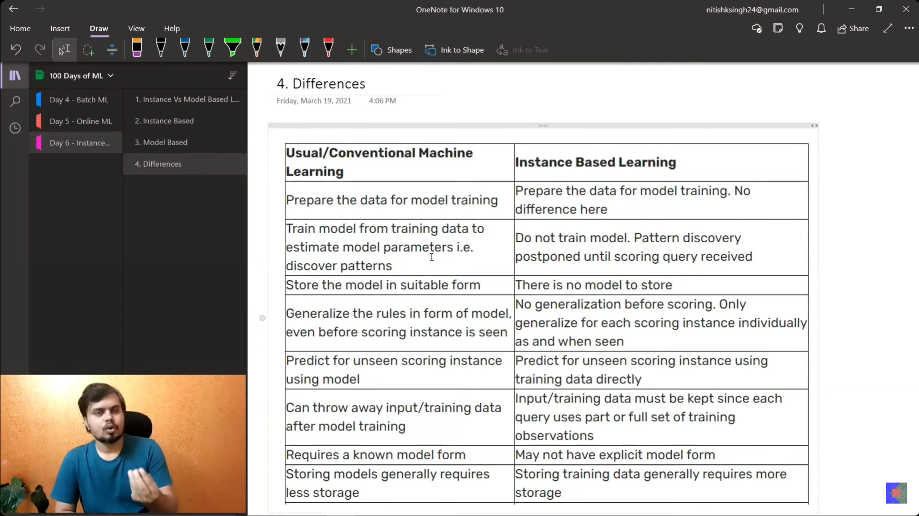

CHALLENGES IN ML
- Data collection(API, WEB SCRAPING)
- INSUFICIENT DATA/LABELLED DATA
  - 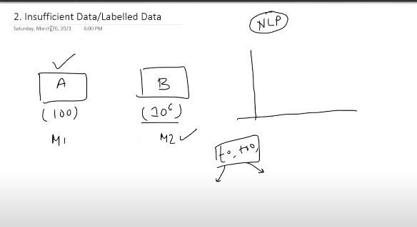
  - Model B is choosen over Model A.
- NON Representative Data
  - What we have becuae of data
    - 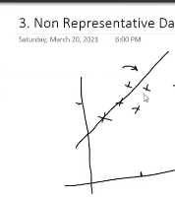
    - Actual is with all data:
      - 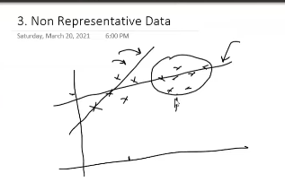
    - sampling noise:
asking who will win in world cup to Indians.
    - sampling bias
Asking who will in in world cup all over the world only to Indian fans.

- Poor quality data:
  - outliers, missing values, abrupt values.
  - 60% time of the project spent only on the correcting data.
- Irrelavant features:
  - There are columns, not contributing to the analysis.
  - EX: Marathon
    - 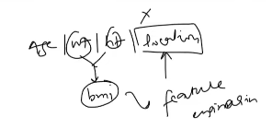
- Overfitting: less training loss and more test loss.
  - 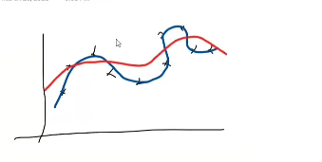
  - Blue is overfit and red is actually we needed.
- Underfiting: More training loss and more test loss.
  - very simpler models whle dealing with the complex data.
  - 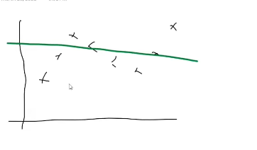

- Software integration:
- Offline learning/ Deployment
- Cost involved

- Application of ML:

  - Retail - Amazon
    - Increase the stocks of some product based only previous years sales. So by buying it in mass selling and selling those will improve my buisiness.
    - profile analysis: If you are not buying the product, you are the product.
    - Apriori : Keeping the items sde by side based on the analysis of data.
  - Banking and Finance:
    - Matching your profile with the daefaulters profile, if matched, then you will not get loan.
  - Transportation: There are some time hikes where the area depends on how much you earn, called the peak times analysis. Demand more supply is less, so increasing the return at some time will increase the profit.
    - 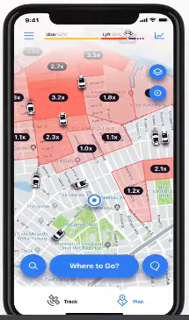
  - Manufacturing:
    - 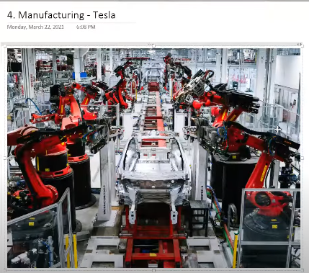
  - sentiment analysis:
    - Based on the election vote polling, based on the majority of votes, I got to know BJP is going to win. So I invest in teh companies that gives much importance to the BJP. BJP won, stcoks increased and hence we got profit and hug money.

- Machine learning development life cycle[ML DLC]
  - Frame the Problem(important at the start), we need to decide some things , because somthings will cost you much
    - what to solve, who are customers, what is teh cost, how many number of people are required to be in a team, how to show the end product, machine learning model to be unsupervised or supervised, batch mode or online mode, which algo to be used, where to get the data.
  - Gathering the data
    - 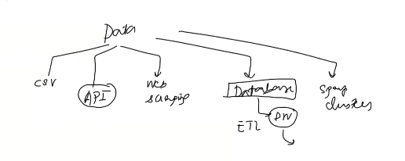
  - Data Preprocessing:
    - 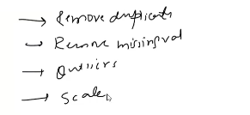
  - Exploratory data analysis:
    - 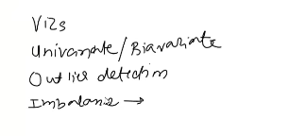
  - Feature Engineering and Selection
    - input(features) :
      - Ex:House price prediction
        - Different number of features, like number of rooms, number of washrroom, kitchen
        - W can remove the above mentioned and need to insert the new. square feet, which is a feature which can help me in many ways.

    - feature selection, remove the features that do not impact, more columns will impact the training time.
  - Model training and evaluation and selection
    - We do not know , which algorithm is going to perform better on which kind of data.
    - We apply different machine learning models an based on that we are going to make the evaluation and training, then select based on the metrics.
  - Model deployment:
    - API
    - 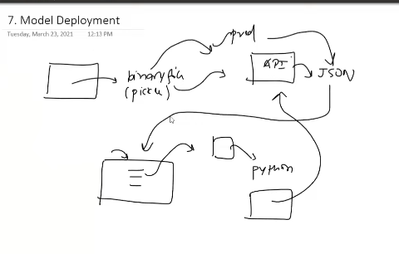
  - Testing:
    - A/B testing
  - Optimise
    - 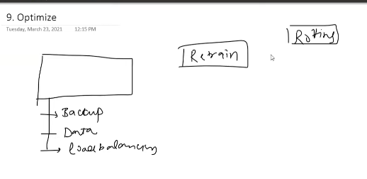
    - Rotting: The system becomes older and unuable, because of the new data coming in.

  - Data Engineering
    - 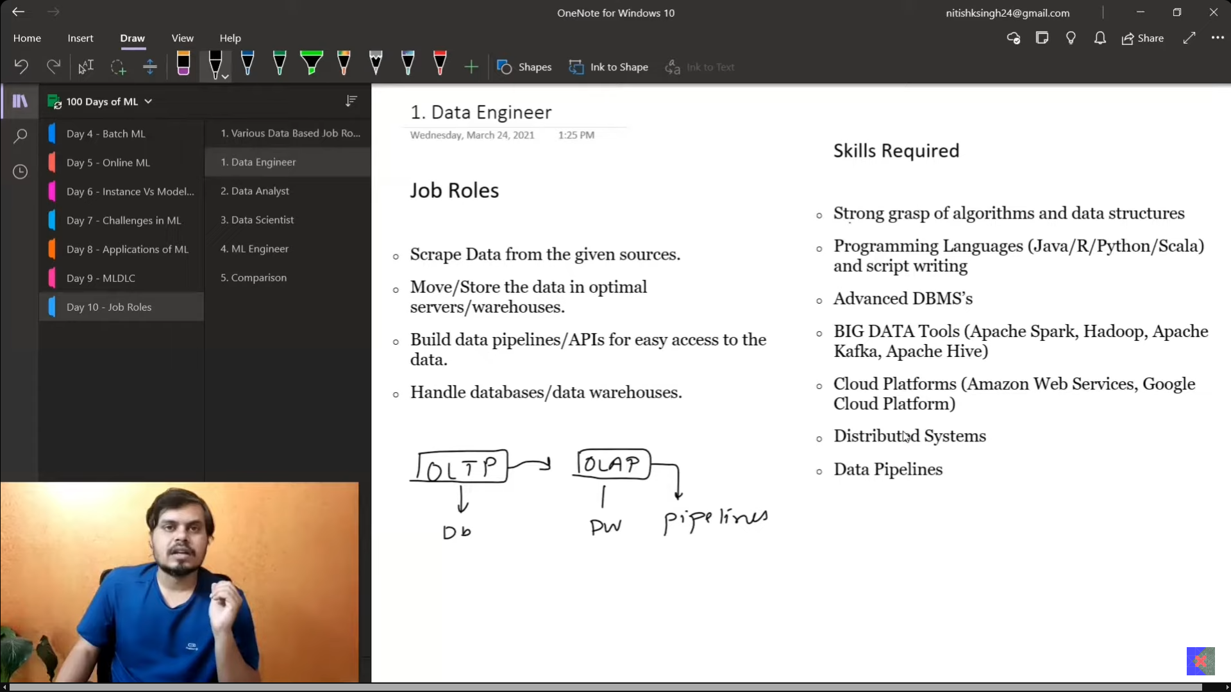
  - 
  - 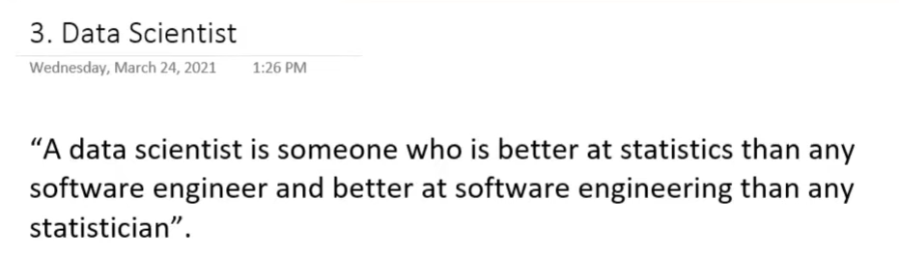
  - 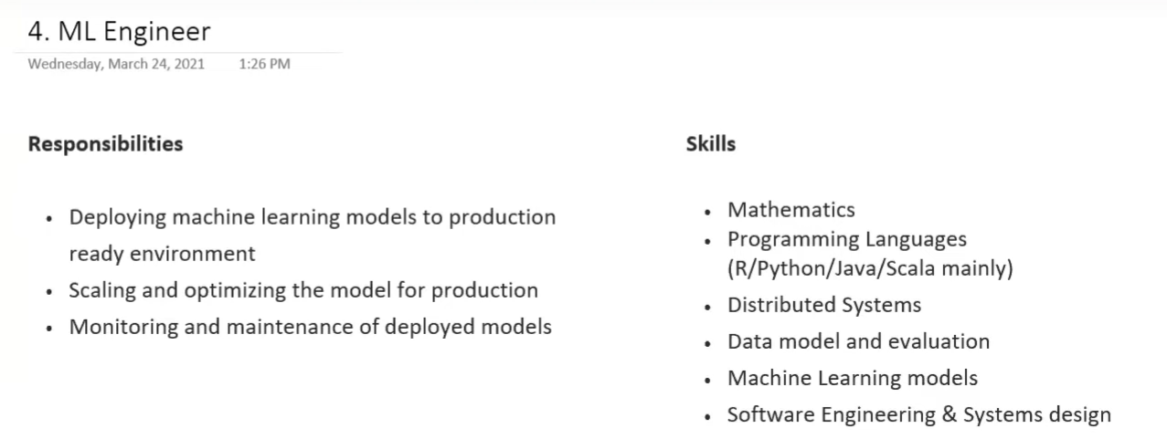
  - 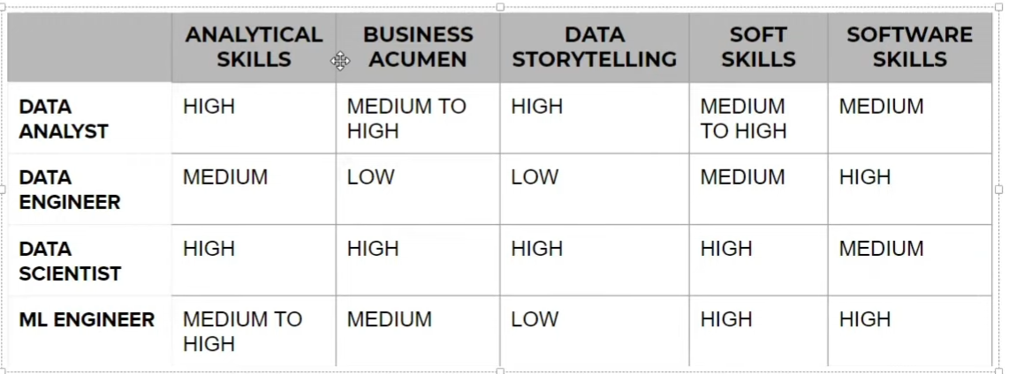

- TENSORS
  - It is more like a container for numbers.
  - 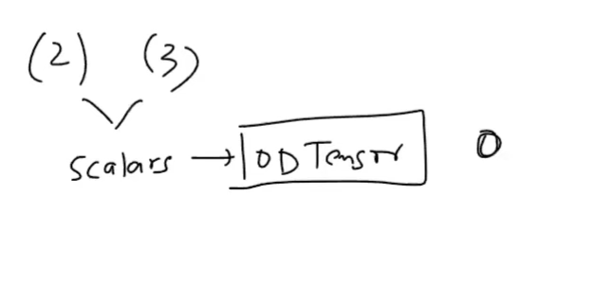
  - 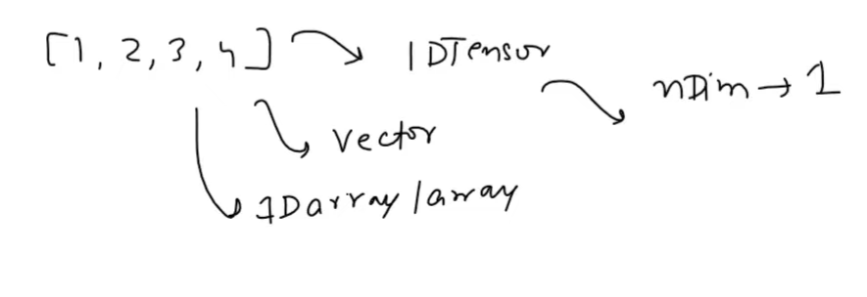
  - 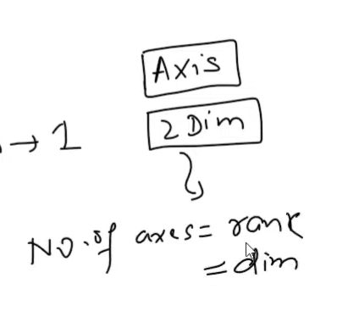
  - 1d tensor with vector 4D,
    - Number of axes required to represent the data is 1. Rank =1.
    - 4D vector- within the 1d axis array we have 4 elements.
  - Axes - The number of axes needed in order to represent the data. (array.ndim)
  - 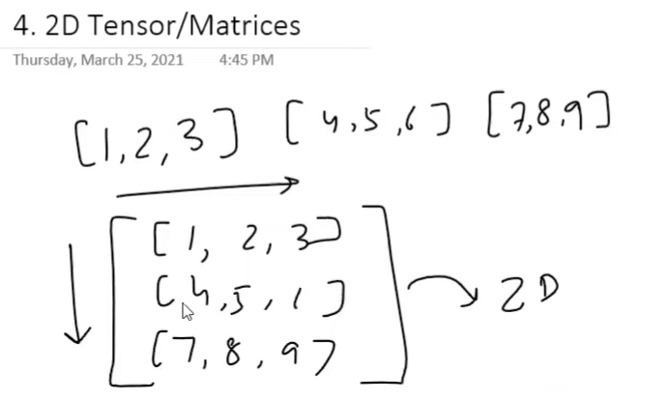
  - 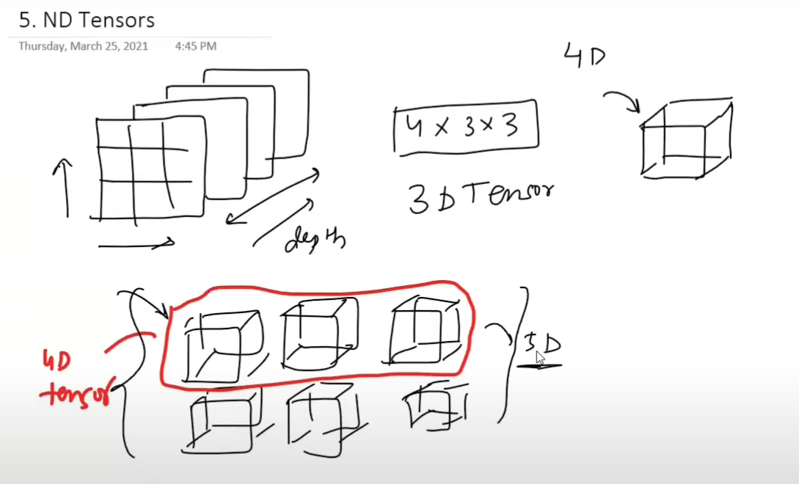
  - Machine learning will focus more on the 0 to 5d tensors.
  - 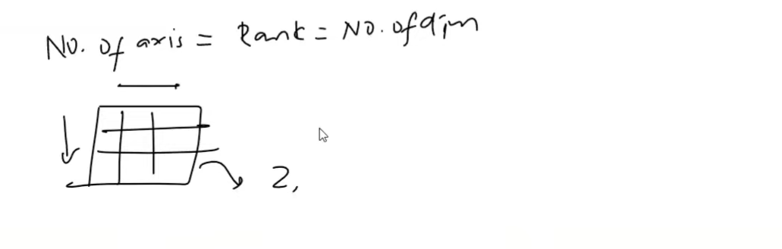
  - size = total number of elements in the array/vector.
  - 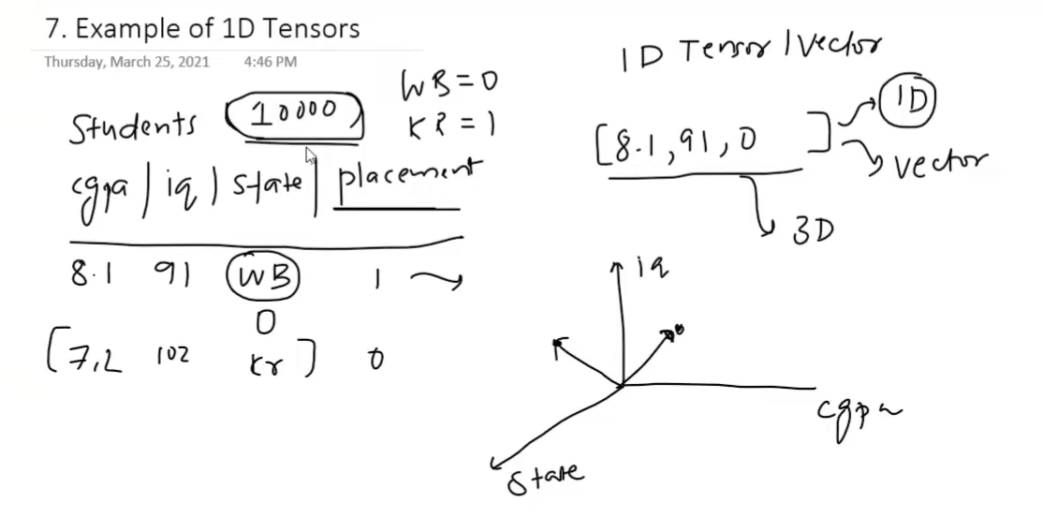
  - 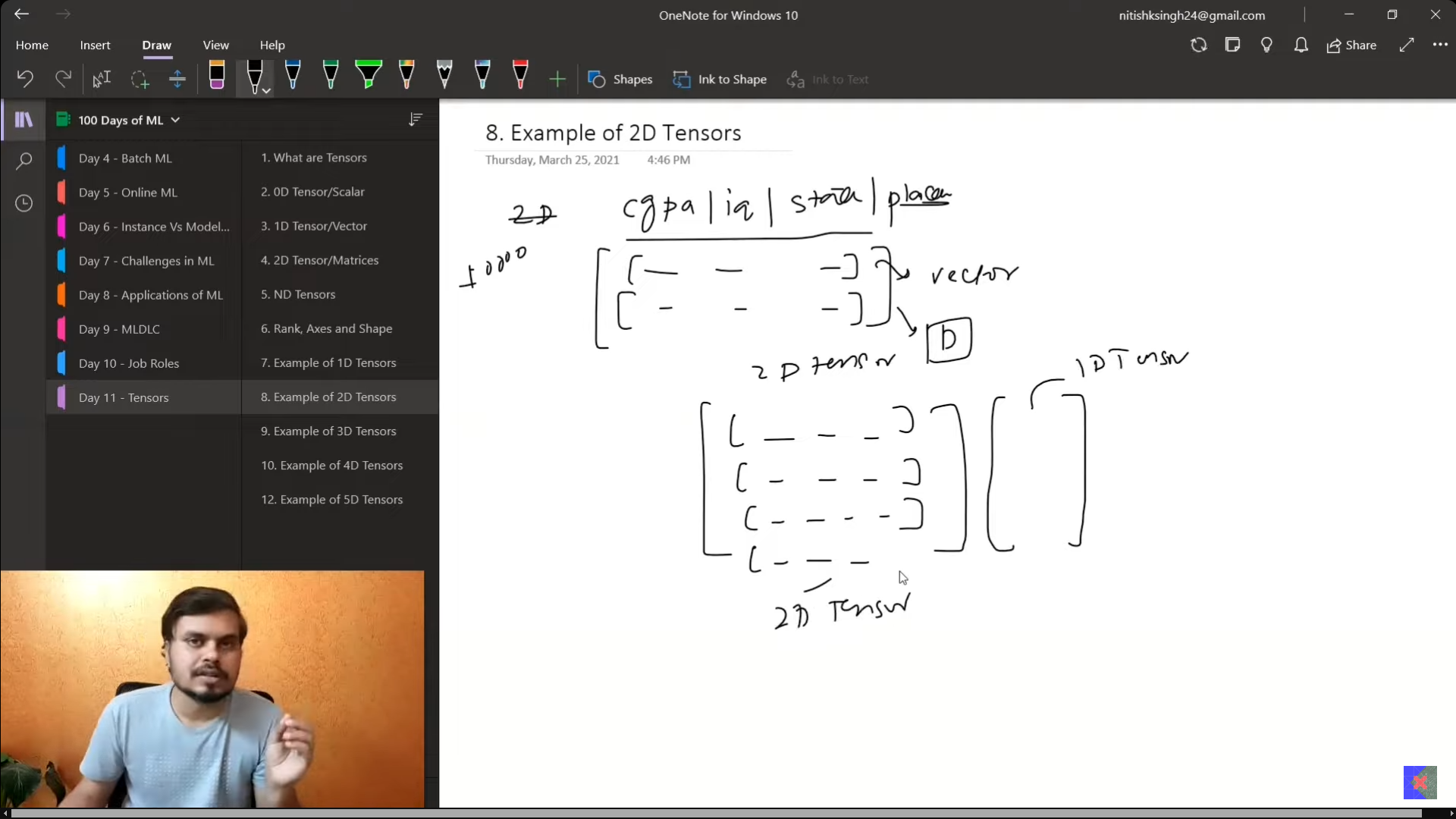
  - 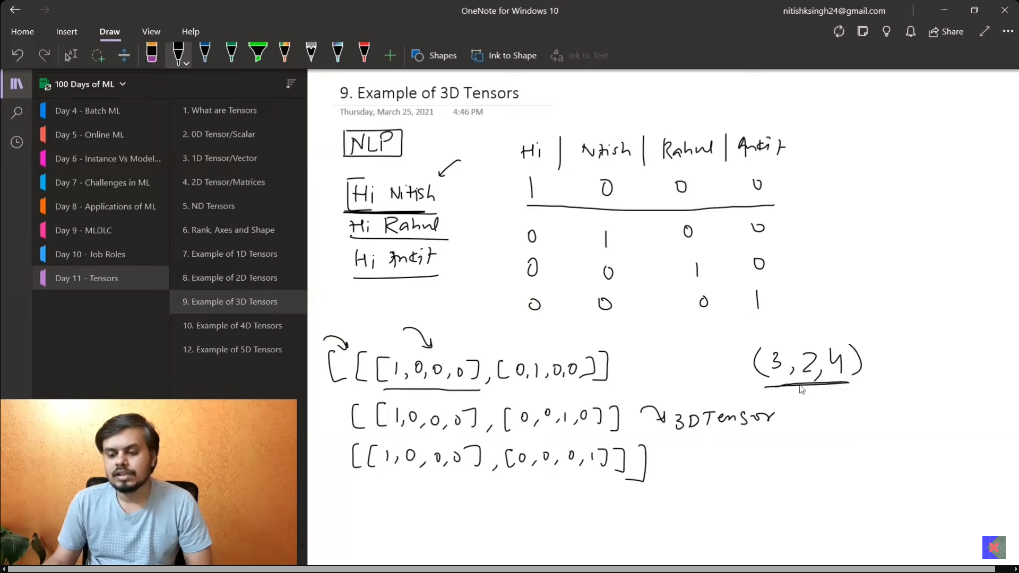
  - 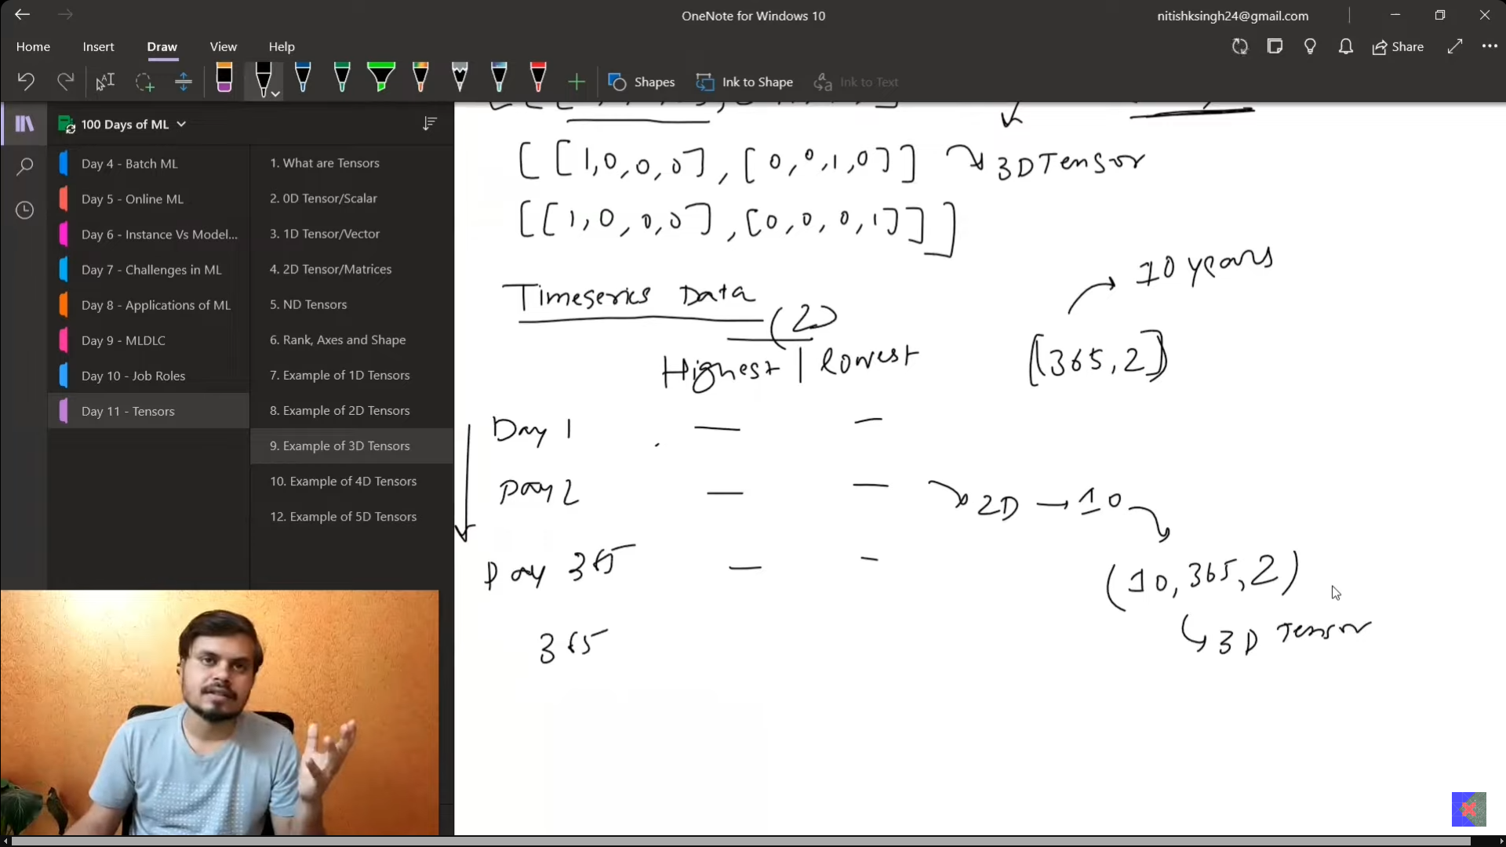
  - 
  - If more than 12fps then our human mind is going to consider the series of the images as videos.
  - 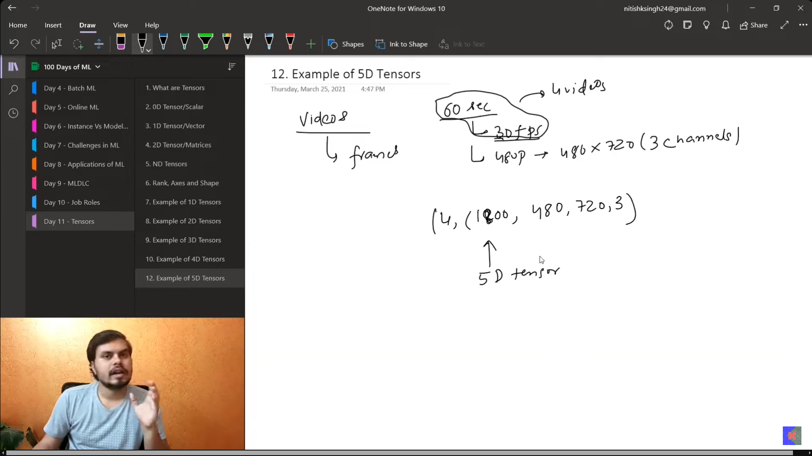

- How to formulate the machine learning problem
  - Converting from buisness problem yo machine learning problem, means turning to mathematics and making specific target to each the secific target.
  - Type of problem
    - Identify the problem .
      - Consider a superveised problem, of churnign, understanding the behaviours early, making the decision based n the above.
      - But the problem still arises from the above, what about the people who definitley want to leave and some may be state? Based on that, give the rate of discount.
  - Current solution
  - Getting data
    - 
- Gathering data
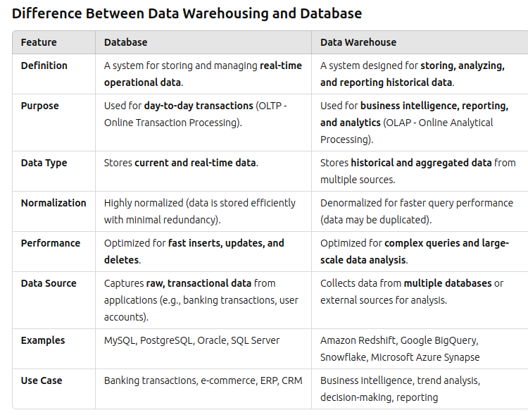

  - CSV
import requests
from io import StringIO

req = request.get(url, headers= headers)
data = StringIO(req.text)
pd.read_csv(data)

parameters in pd.read_csv():
- sep=”\t, , \n, ”
- names=[values], These are usd for the sake of keeing the names of the columns.
- index_col=”name_of_column”, so along the rows from topp to bottom, the names in the column becomes the index.
- header=value
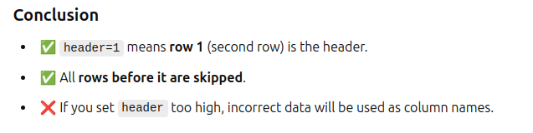
- use_cols=[‘’]- loads only these columns.
- squeeze=True, when we use this along with teh above it is going to convert the dataframe to be returned into the Series format.
- skiprows=[0,1]/
- nrows=100, this is used for extracting the same number of rows from the data. Helps when we have hell lot when we have hell lot of data.
- encoding=’latin-1’
  - When there is UnicdoeDecodeError, this to be used.
- skiprows
  - error_bad_lines = False
  - Expecting all the rows with the same number of columns, but sometimes we have more than expected, so in those times, this comes into picture.
- dtype
  - dtype={‘target’: type_of_the_column}
- Handling Dates
  - parse_dates=[‘column_names’]
  - parse_dates=[{name: [1,2]}] - this is used for combining bit the columns 1 and 2 and makes the combined column and names it as single column.

- Convertors:
  - 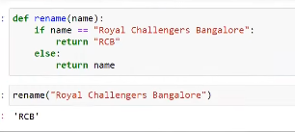
  - 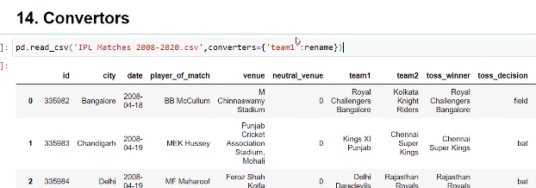

- na_values:
  - na_value=[‘list of values’] - f anywhere these values are found seperatley then thsese are considered to be NaN values.
- Loading a huge dataset in chunks
  - chunksize= value, will divide the whole columns in equal chunks.

  - JSON
    - pd.read_json(data)
    - pd.read_json(url)
  - df.append(ignore_index = True) - pandas creates ints own indxe values rather than keeping 1 to 20, 1 to 20 etc, etc like this.

  - SQL
    - 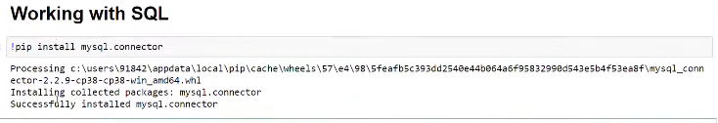
    - 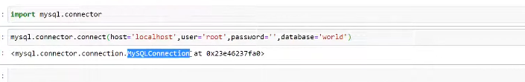
    - 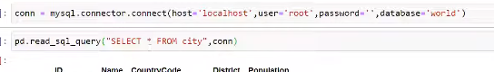

  - API-FETCH
    - 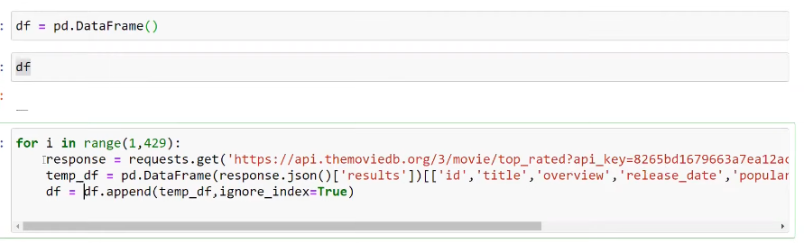
    - make these kinds of data, then upload this to kaggle, how to find apis?? Rapid APIs
    - 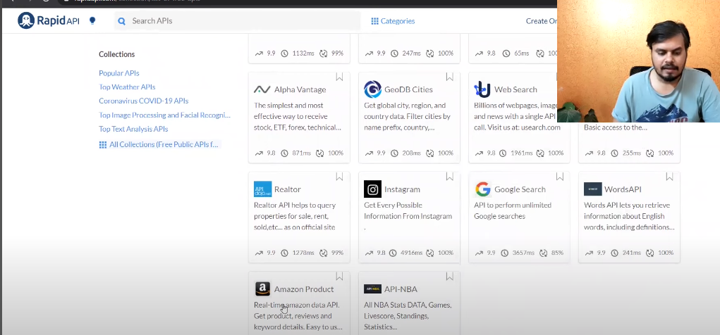
  - WEB SCRAPING
    - 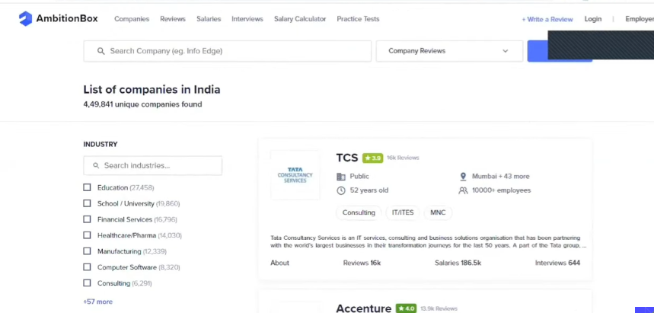
    - 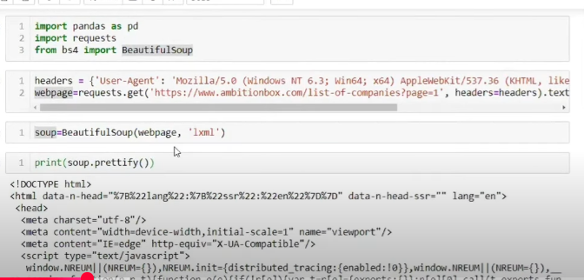

    - s

  - s
- Understanding the data
  - 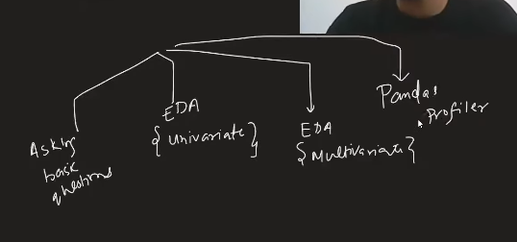

  - 7 questions, primitive
    - big data -> df.shape
    - data look like-> df.head(), df.sample(5)
    - data types of cols -> df.info()
      - How to reduce the size of the whole data-> convertinf from float 64 to 32bit int.
    - are there many values are null-> df.isnull().sum()
    - how does the data look mathematically-> df.describe()
      - On every numerical column, we get the statistical measure.
    - duplicate values??
      - df.duplicated().sum()
      - Tells how many number of rows are duplicated
    - Correlation between the cols??
      - df.corr()

  - Univariate analysis:
    - Analysing each and every columnn seperatley is called the univariate analysis. If 2 columns are involved then it is called bi-variate analysis, if more than 2 is called multi-variate analysis.
    - First focus on categorical data, then comes to nuermical data
    - categeory:
      - countplot - How many number of times the different catgeories came.
        - df[‘col_name’].value_counts().plot(kind=’bar’)
        - sns.countplot(df[‘survived’])
      - piechart
        - df[‘column_name’].value_counts().plot(kind=’pie’, autopct=’%.2f’)

    - Numerical Data
      - Histogram:

      - s

- s

